**Una red LAN está formada por 4 PC conectados a un conmutador capaz de soportar redes VLAN. Se pide:**

1. **Crear 2 VLAN**.

**VLAN 10:**

PAR05>enable

PAR05#configure terminal

Enter configuration commands, one per line. End with CNTL/Z.

PAR05(config)#vlan 10

PAR05(config-vlan)#name Primera

PAR05(config-vlan)#exit

PAR05(config)#interface fastethernet 0/1

PAR05(config-if)#switchport mode access

PAR05(config-if)#switchport access vlan 10

PAR05(config-if)#exit

PAR05(config)#interface fastethernet 0/2

PAR05(config-if)#switchport mode access

PAR05(config-if)#switchport access vlan 10

PAR05(config-if)#exit

PAR05(config)#

PAR05#exit

**VLAN 20**:

PAR05>enable

PAR05#configure terminal

PAR05(config)#vlan 20

PAR05(config-vlan)#name Segunda

PAR05(config-vlan)#interface fastethernet 0/3

PAR05(config-if)#switchport mode access

PAR05(config-if)#switchport access vlan 20

PAR05(config-if)#exit

PAR05(config)#interface fastethernet 0/4

PAR05(config-if)#switchport mode access

PAR05(config-if)#switchport access vlan 20

PAR05(config-if)#exit

PAR05(config)#exit

PAR05#exit

1. **Mostrar las VLAN creadas**.

PAR05>enable

PAR05#show vlan brief

VLAN Name Status Ports

---- -------------------------------- --------- -------------------------------

1 default active Fa0/5, Fa0/6, Fa0/7, Fa0/8

Fa0/9, Fa0/10, Fa0/11, Fa0/12

Fa0/13, Fa0/14, Fa0/15, Fa0/16

Fa0/17, Fa0/18, Fa0/19, Fa0/20

Fa0/21, Fa0/22, Fa0/23, Fa0/24

10 Primera active Fa0/1, Fa0/2

20 Segunda active Fa0/3, Fa0/4

1002 fddi-default active

1003 token-ring-default active

1004 fddinet-default active

1005 trnet-default active

PAR05#

1. **Comprobar que las VLAN creadas funcionan como tal**.

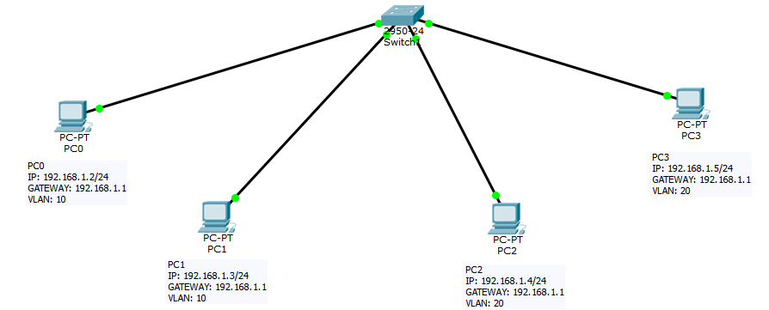

**Ahora para mostrar el funcionamiento de las Vlan haremos un serie de "ping" para ver de que máquinas recibimos respuesta y de cuáles no.**

**PING PC0 a PC1 (VLAN 10) y PING PC0 A PC3 Y PC4 (vlan 20)**:

PC>ping 192.168.1.3

Pinging 192.168.1.3 with 32 bytes of data:

Reply from 192.168.1.3: bytes=32 time=0ms TTL=128

Reply from 192.168.1.3: bytes=32 time=1ms TTL=128

Reply from 192.168.1.3: bytes=32 time=0ms TTL=128

Reply from 192.168.1.3: bytes=32 time=9ms TTL=128

Ping statistics for 192.168.1.3:

Packets: Sent = 4, Received = 4, Lost = 0 (0% loss),

Approximate round trip times in milli-seconds:

Minimum = 0ms, Maximum = 9ms, Average = 2ms

PC>ping 192.168.1.4

Pinging 192.168.1.4 with 32 bytes of data:

Request timed out.

Request timed out.

Request timed out.

Request timed out.

Ping statistics for 192.168.1.4:

Packets: Sent = 4, Received = 0, Lost = 4 (100% loss),

PC>ping 192.168.1.5

Pinging 192.168.1.5 with 32 bytes of data:

Request timed out.

Request timed out.

Request timed out.

Request timed out.

Ping statistics for 192.168.1.5:

Packets: Sent = 4, Received = 0, Lost = 4 (100% loss),

**Ahora vamos hacer un ping desde los pc alojados en VLAN 20. Desde PC3 a PC2 (VLAN 20) y desde PC3 a PC0-PC1 (VLAN 10)**:

PC>ping 192.168.1.4

Pinging 192.168.1.4 with 32 bytes of data:

Reply from 192.168.1.4: bytes=32 time=1ms TTL=128

Reply from 192.168.1.4: bytes=32 time=0ms TTL=128

Reply from 192.168.1.4: bytes=32 time=14ms TTL=128

Reply from 192.168.1.4: bytes=32 time=0ms TTL=128

Ping statistics for 192.168.1.4:

Packets: Sent = 4, Received = 4, Lost = 0 (0% loss),

Approximate round trip times in milli-seconds:

Minimum = 0ms, Maximum = 14ms, Average = 3ms

PC>ping 192.168.1.3

Pinging 192.168.1.3 with 32 bytes of data:

Request timed out.

Request timed out.

Request timed out.

Request timed out.

Ping statistics for 192.168.1.3:

Packets: Sent = 4, Received = 0, Lost = 4 (100% loss),

PC>ping 192.168.1.2

Pinging 192.168.1.2 with 32 bytes of data:

Request timed out.

Request timed out.

Request timed out.

Request timed out.

Ping statistics for 192.168.1.2:

Packets: Sent = 4, Received = 0, Lost = 4 (100% loss),

CUESTIÓN 2

Dada una red como la de la figura siguiente.

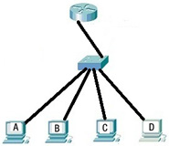

Se pide:

1. **Crear dos subinterfaces en el router.**

Router>enable

Router#configure terminal

Router(config)#hostname RouterPAR05

RouterPAR05(config)#interface fastethernet 0/1

RouterPAR05(config-if)#no shutdown

RouterPAR05(config-if)#exit

RouterPAR05(config)#interface fastethernet 0/1.2

RouterPAR05(config-subif)#

%LINK-5-CHANGED: Interface FastEthernet0/1.2, changed state to up

%LINEPROTO-5-UPDOWN: Line protocol on Interface FastEthernet0/1.2, changed state to up

RouterPAR05(config)#interface fastethernet 0/1.3

RouterPAR05(config-subif)#

%LINK-5-CHANGED: Interface FastEthernet0/1.3, changed state to up

%LINEPROTO-5-UPDOWN: Line protocol on Interface FastEthernet0/1.3, changed state to up

RouterPAR05(config-subif)#exit

RouterPAR05(config)#exit

RouterPAR05#exit

1. **Asociar las subinterfaces a dos VLAN diferentes que se encuentren en dos redes diferentes (192.168.1.0 y 192.168.2.0).**

RouterPAR05(config)#interface fastEthernet 0/1.2

RouterPAR05(config-subif)#description Dos VLAN2

RouterPAR05(config-subif)#encapsulation dot1Q 2

RouterPAR05(config-subif)#ip address 192.168.1.1 255.255.255.0

RouterPAR05(config-subif)#exit

RouterPAR05(config)#interface fastEthernet 0/1.3

RouterPAR05(config-subif)#description Tres VLAN3

RouterPAR05(config-subif)#encapsulation dot1Q 3

RouterPAR05(config-subif)#ip address 192.168.2.1 255.255.255.0

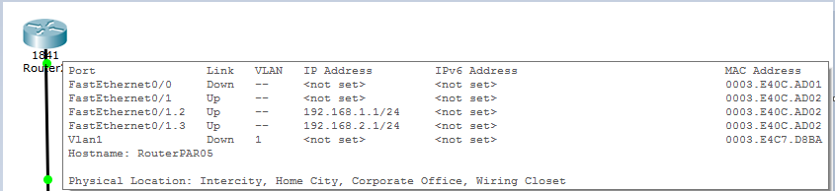

1. **Las VLAN a las que se hace referencia en el ejercicio 5 deben contener a los 4 PC, la mitad en cada VLAN. Escribe la dirección IP, máscara de red y puerta de enlace que deben tener cada uno de ellos.**

**Vlan2**:

**PC0 IP**: 192.168.1.2/24 **Mascara de red**:(255.255.255.0) **Puerta de enlace**: 192.168.1.1 **PC1 IP**: 192.168.1.3/24 **Mascara de red**:(255.255.255.0) **Puerta de enlace**: 192.168.1.1

**Vlan3**:

**PC2 IP**: 192.168.2.2/24 **Mascara de red**:(255.255.255.0) **Puerta de enlace**: 192.168.2.1 **PC3 IP**: 192.168.2.3/24 **Mascara de red**:(255.255.255.0) **Puerta de enlace**: 192.168.2.1

1. **Si las VLAN a las que se hace referencia están creadas en el conmutador, escribir la configuración que hace posible que el enlace troncal esté en la interfaz** **FastEthernet0/1 del conmutador.**

PAR05>enable

PAR05#configure terminal

Enter configuration commands, one per line. End with CNTL/Z.

PAR05(config)#int fa 0/1

PAR05(config-if)#switchport mode trunk

PAR05(config-if)#switchport trunk allowed vlan add 2

PAR05(config-if)#switchport trunk allowed vlan add 3

PAR05(config-if)#exit

PAR05(config)#exit

PAR05#show interfaces trunk

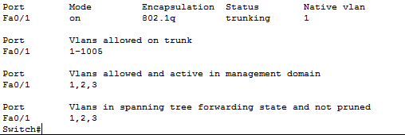

Podemos ver como vlan 1 está incluida en la interface 0/1. Para arreglar esto hacemos lo siguiente:

PAR05#configure terminal

PAR05(config)#int fa 0/1

PAR05(config-if)#switchport trunk allowed vlan remove 1

PAR05(config-if)#exit

PAR05(config)#exit

PAR05#show interfaces trunk

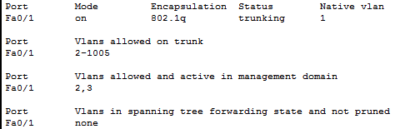

1. **Escribir la configuración que crea las VLAN 2 y 3 en el conmutador.**

PAR05(config)#vlan 2

PAR05(config-vlan)# name Dos

PAR05(config-vlan)#exit

PAR05(config)#vlan 3

PAR05(config-vlan)#name Tres

PAR05(config)#exit

PAR05(config)#show vlan

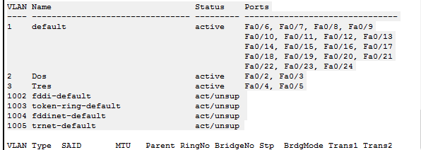

1. **Escribir las órdenes que permiten asociar 2 interfaces disponibles a la VLAN 2 y otras dos a la VLAN 3.**

PAR05(config)#interface fastEthernet 0/2

PAR05(config-if)#switchport mode access

PAR05(config-if)#switchport access vlan 2

PAR05(config-if)#exit

PAR05(config)#interface fastEthernet 0/3

PAR05(config-if)#switchport mode access

PAR05(config-if)#switchport access vlan 2

PAR05(config-if)#exit

PAR05(config)#interface fastEthernet 0/4

PAR05(config-if)#switchport mode access

PAR05(config-if)#switchport access vlan 3

PAR05(config-if)#exit

PAR05(config)#interface fastEthernet 0/5

PAR05(config-if)#switchport mode access

PAR05(config-if)#switchport access vlan 3

PAR05(config-if)#exit

1. **Escribir los comandos que hacen que todas las configuraciones anteriores sean las configuraciones que tenga el switch en su próximo reinicio.**

PAR05#copy running-config startup-config

Por último haremos una serie de pruebas para ver si los equipos tienen comunicación entre ellos:

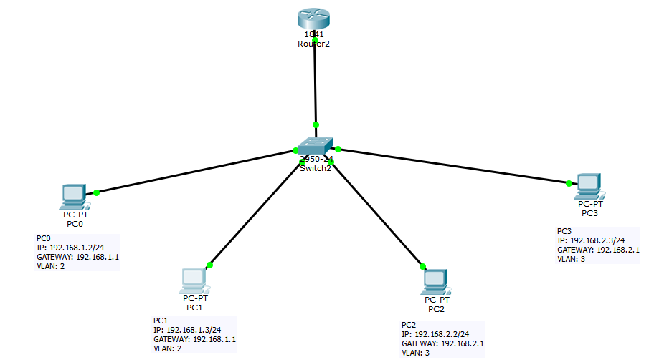

Realizamos un PING desde el PC0 a todas las máquinas:

PC>ping 192.168.1.3

Pinging 192.168.1.3 with 32 bytes of data:

Reply from 192.168.1.3: bytes=32 time=1ms TTL=128

Reply from 192.168.1.3: bytes=32 time=1ms TTL=128

Reply from 192.168.1.3: bytes=32 time=0ms TTL=128

Reply from 192.168.1.3: bytes=32 time=0ms TTL=128

Ping statistics for 192.168.1.3:

Packets: Sent = 4, Received = 4, Lost = 0 (0% loss),

Approximate round trip times in milli-seconds:

Minimum = 0ms, Maximum = 1ms, Average = 0ms

PC>ping 192.168.2.2

Pinging 192.168.2.2 with 32 bytes of data:

Reply from 192.168.2.2: bytes=32 time=1ms TTL=127

Reply from 192.168.2.2: bytes=32 time=1ms TTL=127

Reply from 192.168.2.2: bytes=32 time=1ms TTL=127

Reply from 192.168.2.2: bytes=32 time=1ms TTL=127

Ping statistics for 192.168.2.2:

Packets: Sent = 4, Received = 4, Lost = 0 (0% loss),

Approximate round trip times in milli-seconds:

Minimum = 1ms, Maximum = 1ms, Average = 1ms

PC>ping 192.168.2.3

Pinging 192.168.2.3 with 32 bytes of data:

Reply from 192.168.2.3: bytes=32 time=0ms TTL=127

Reply from 192.168.2.3: bytes=32 time=0ms TTL=127

Reply from 192.168.2.3: bytes=32 time=1ms TTL=127

Reply from 192.168.2.3: bytes=32 time=0ms TTL=127

Ping statistics for 192.168.2.3:

Packets: Sent = 4, Received = 4, Lost = 0 (0% loss),

Approximate round trip times in milli-seconds:

Minimum = 0ms, Maximum = 1ms, Average = 0ms